Author:

Liu Zhiheng, Zhou Honghao

University:

Nanyang Technological University

Tutor:

Miss. Pang Su Woon

Date of Submission:

25/10/2017

|  |  |
| --- | --- |
| C:\Users\Zayn Leo\AppData\Local\Microsoft\Windows\INetCache\Content.Word\photo_2017-10-20_09-29-07.jpg  Club assistant | A powerful software application, which targets on student organizations. |

**Background**

Currently, NTU is providing rich opportunities​​ for over 100 student organizations to form and grow. (NTU, 2017) Organizing student activity creates a great platform for club members to share knowledge and experiences.

To invite members for an activity, the ExCo (Executive Committee) will send emails and require the members to submit their personal information through Google Form, an online application which helps create surveys and gather responses. (Wolber, 2012) In this way, the ExCo can collect participants’ profiles to organize the activity.

**Problem**

However, currently, signing up activities is troublesome.

1. It is unreliable and inefficient to invite members for an activity through emails.

Mailboxes are often saturated with different information. Therefore, the invitation may fail to grab members’ attention.

To solve this problem, the ExCo will send replicates to members. However, Google Forms accept multiple submission from the same person. Hence, if someone registers more than once, the ExCo will receive the inaccurate number of participants.

1. It is inconvenient for members to repeatedly submit personal information for every activity.

Since currently, no online application can help student organizations automatically read and use members’ profile. The ExCo should require each member to provide personal information to create a new name list through Google Forms.

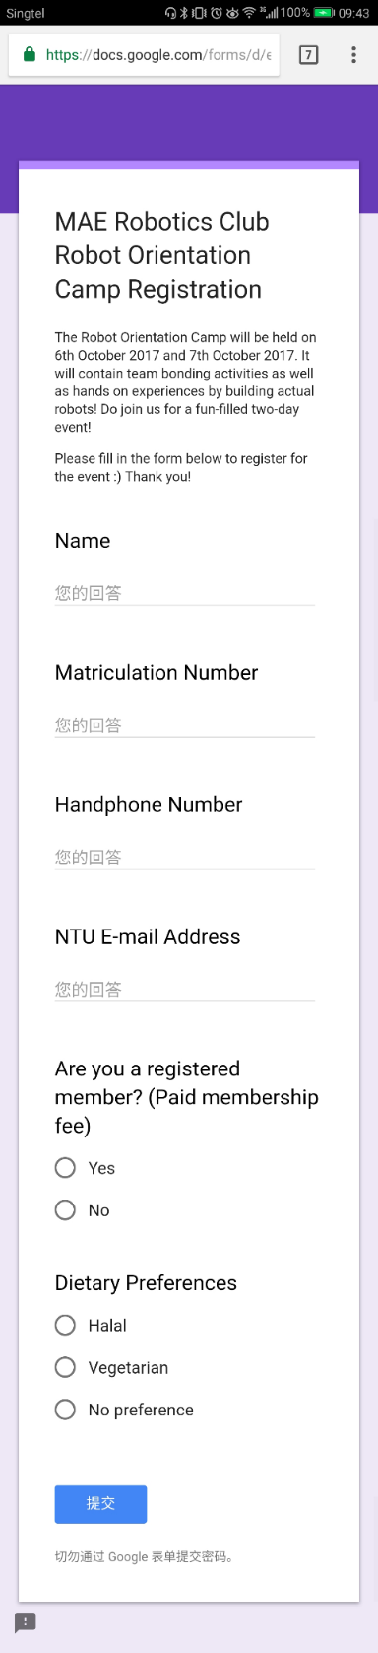

One should answer the same survey repeatedly.

This method is unfriendly and can be improved by software.

**Proposed Solution**

We use “Bot” to facilitate the registration process.

**Bots** are free Telegram accounts operated by software. They allow programmers to create online applications within a message service, Telegram. (The Telegram Team, 2015)

“Club Assistant” is a specially designed bot, which targets on student organizations. It can collect members’ information, store it in databases, and make use of it efficiently.

The mechanism of Club Assistant is described below:

1. President can install the bot, set the club information, and assign the ExCo.
2. Then, the members should submit their profile through Club Assistant.

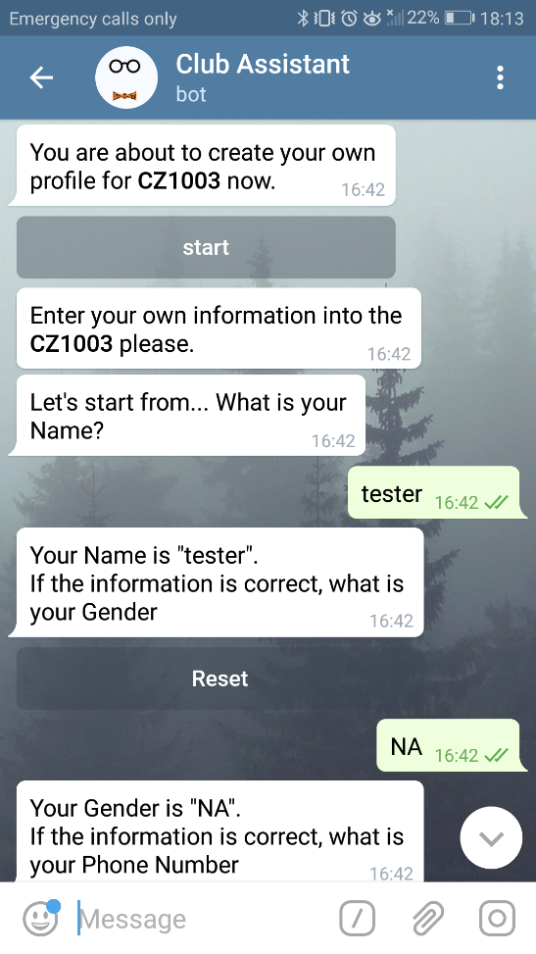

1. The application will read each member’s information and store it in the main database. 

The ExCo can read databases with excel.

1. The ExCo can create activities through Club Assistant by setting the pre-event survey, sending invitations, announcements, files, and online references.

The application reads all the messages and automatically sends the messages to the members.

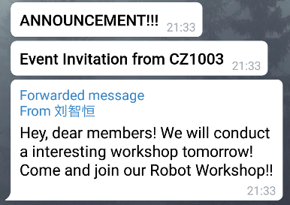

Meanwhile, a new event database is created.

1. For registration, a member simply needs to
2. click on the registration button,

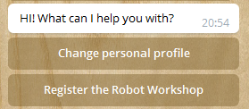

1. answer the pre-event survey



1. check if his profile needs updating.

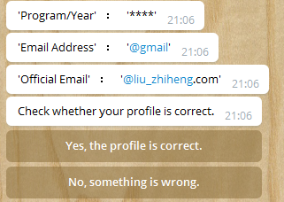

If so, the application will ask him to change the specific information,

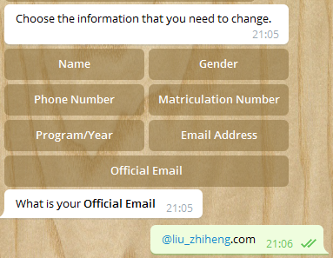

read his message, and ask for confirmation,

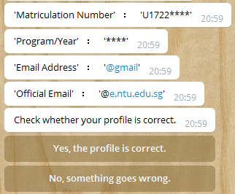

finally, update the information in databases.

1. After confirmation, the application will copy his profile from the main database and write it into the event database with his answers to the survey.
2. When registration is closed, the application will send the event database to the ExCo for checking the participants’ information.

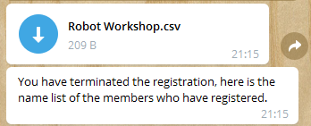

Through Club Assistant, the invitation messages and references are sent to each member privately and the members need not resubmit their profiles for registration. Hence, the efficiency and convenience for registration are greatly improved.

**Benefits**

Club Assistant will benefit both club officers and members.

1. Reliable

Through this application, firstly, the messages and the registration links are sent to unregistered members privately. Secondly, there will not be any unrelated information on the interface.

With easy access to read all the invitation and references, members can always rely on the application for club announcement.

1. Safe and private

The application has a hierarchy system with encrypted databases.

1. The application can store the databases safely. The student organization will never lose the files, even if the computer breaks down.
2. The databases will not be stolen on the internet. Only the ExCo can retrieve the information, protecting members’ privacy to the largest extent.
3. Easy and Clean

The application can intelligently process the messages and choose the recipients.

1. Members can easily register activities by clicking a button.
2. Unregistered members will not be spammed by any information or announcements during the activity.

**Implementation**

To develop Club Assistant, the following steps are conducted.

1. Create a bot account on the platform provided by Telegram.
2. Design the algorithm and implement it with the programming language, Python.
3. Deploy the application on Heroku, an online application platform, which enables the application run on the internet.
4. Cooperate with student organizations to increase the influence of Club Assistant.

**Cost**

Online Application Platform $50

Software Maintenance $100

Total Cost $150

**Conclusion**

For the ExCo, managing a club is challenging and, for members, registering student activities is always troublesome. With Club Assistant, any club can be well-organized, holding outstanding reliability, convenience, efficiency, and privacy.

Club Assistant is now testing on the MAE robotic club and tends to be commercialized someday.

Word count: 799

# Reference

NTU. (2017, September 12). *Nanyang Technological University*. Retrieved from Clubs & Communities: http://www.ntu.edu.sg/CampusLife/Clubs/Pages/default.aspx

The Telegram Team. (2015, June 24). *Twitter Telegram*. Retrieved from Telegram Bot Platform: https://telegram.org/blog/bot-revolution

Wolber, A. (2012, October 31). *Tech Republic*. Retrieved from Use Google Forms to create a survey: http://www.techrepublic.com/blog/google-in-the-enterprise/use-google-forms-to-create-a-survey/